Quaid-e-azam university  ISLAMABAD

PROJECT MANAGEMENT SYSTEM FOR FINAL YEAR STUDENTS

**NAME:**

SAFEENA AKHTER

**REGISTRATION#:**

04072312008

**PROJECT SUBTITLE:**

USECASE AND SYSTEM SEQUENCE DIAGRAM

**SUBMISSION DATE:**

24TH MARCH 2025

**PROJECT STACKHOLDER:**

DR. ONAIZA MAQBOOL

**BY: SAFEENA AKHTER**

**Use Case UC1: Submit Work Product**

**Primary Actor:**

* Student

**Pre-Conditions:**

* The student must be logged into the system.
* The student must have an assigned project with submission access.

**Post-Conditions:**

* The system stores the submitted file without uploading errors and makes it accessible to the supervisor for review.

**Input:**

* File Upload (PDF, DOCX,ZIP)

**Output:**

* Confirmation message for successful submission.

**Main Success Scenario:**

1. The student navigates to "Submit Work" in the system.
2. The student selects their assigned project.
3. The student uploads the required file(Work product).
4. The system verifies the file format to ensure it is an allowed format (PDF, DOCX, ZIP).
5. The system stores the submission in the database.
6. The student receives a confirmation message stating that the work product document has been submitted and stored in the system.

**Alternative Scenarios:**

1. **Invalid File Format:**
   * The system detects an unsupported file format.
   * The system displays an error message: “Invalid file format. Please upload a PDF, DOCX or ZIP.”
   * The student is prompted to re-upload a valid file.
2. **Internet Failure During Upload:**
   * The system detects an interrupted connection.
   * The system saves the upload progress.
   * Once the internet is restored, the system prompts the student to resume the upload instead of restarting.

**Use Case UC2: Explore Projects**

**Primary Actor:**

* Student

**Stakeholders and Interests:**

* **Student:** Wants to explore available projects and understand their details before registration.

**Pre-Conditions:**

* The user must be logged in to access the project list.
* At least one project must be available in the system.

**Post-Conditions:**

* The system **retrieves and displays** the list of projects with key details, including **title, description, assigned supervisor, and status.**
* The Student can access and read project details without any errors.

**Input:**

* None (The system automatically fetches available projects).

**Output:**

* A list of **available projects** with essential details displayed on the screen.

**Main Success Scenario:**

1. The student navigates to the **"Projects"** section in the system.
2. The system retrieves and displays all available projects with details (title, description, assigned supervisor, and current status).
3. The student selects a project to view more details.

**Alternative Scenarios:**

1. **No Available Projects:**
   * The system detects that no projects are available for viewing.
   * The system displays a message: *"*Currently, no projects are available. Please check back later."
2. **Permission Issue:**

* The student attempts to view projects but lacks permission as it already taken by another student.
* System displays: “**Access Denied: This project has already been registered by another student. Please choose a different available project.”**

1. **System Failure:**
   * A temporary issue prevents projects from loading.
   * The system displays an error: *"Unable to retrieve projects. Please try again later."*

**Use Case UC3: Give Feedback**

**Primary Actor:**

* Supervisor

**Stakeholders and Interests:**

* **Supervisor:** Wants to review student submissions and provide constructive feedback.
* **Student:** Needs feedback to improve their work and meet project requirements.

**Pre-Conditions:**

* The supervisor must be logged into the system.
* The student must have **submitted** a work product.

**Post-Conditions:**

* The system confirms that feedback has been stored and immediately notifies the student to check the feedback of their relevant work product.

**Input:**

* Text feedback
* Optional file attachment (PDF, DOCX)

**Output:**

* Confirmation message stating: **"Your feedback has been recorded and is now visible to the student."**
* The system notifies the student via email or dashboard alert.

**Main Success Scenario:**

1. The supervisor navigates the "Work Submissions" section.
2. The system displays a list of student-submitted work products.
3. The supervisor selects a submission to review.
4. The supervisor enters feedback in the provided text field.
5. (Optional) The supervisor uploads an attachment for additional feedback.
6. The supervisor submits the feedback.
7. The system stores the feedback and notifies the student.

**Alternative Scenarios:**

1. **No Submissions Available:**
   * The system displays a message: **"No work products available for feedback."**
   * The supervisor is redirected to the dashboard.
2. **System Failure During Submission:**
   * The system fails to store feedback due to an error.
   * The supervisor receives a message: **"Feedback submission failed. Please try again later."**
3. **Internet Connection Failure:**

* The system detects a network issue during feedback submission.
* The system temporarily saves the feedback draft.
* Once the internet is restored, the system prompts the supervisor to **"Resume Submission"** instead of restarting.

**Submit Work Product SSD:**

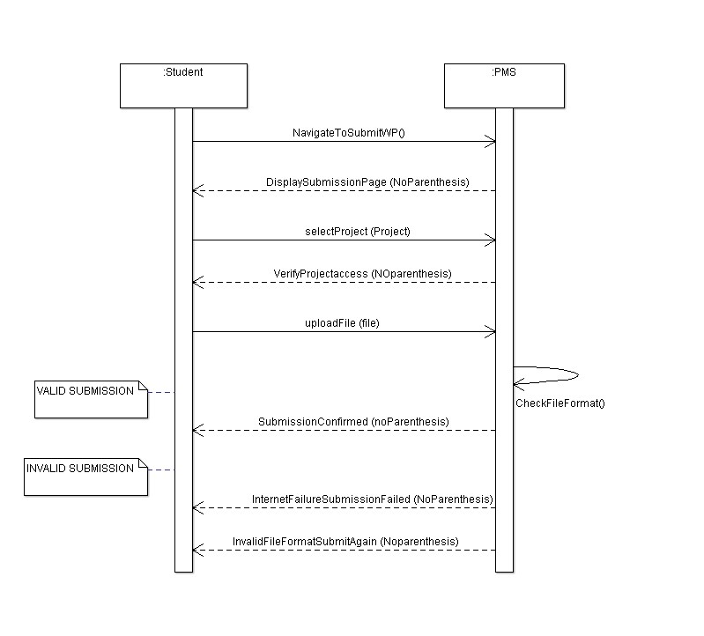

**Explore Projects SSD:**

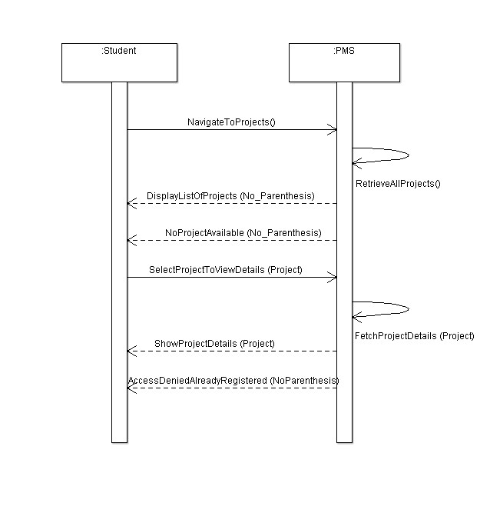

**Gives Feedback SSD:**

